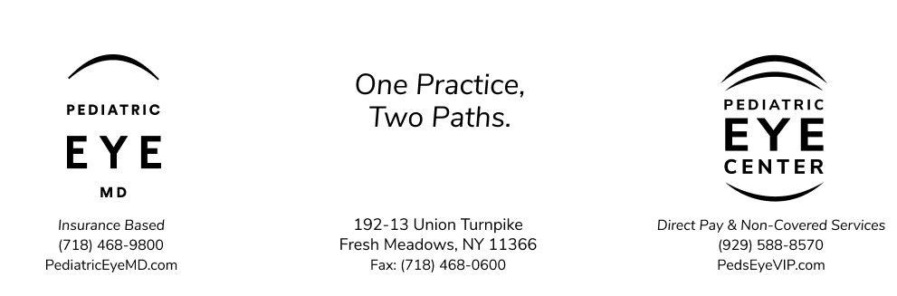

Medical Records Release Request

Patient Name:
Patient Address:
Patient DOB:

I am the legal guardian of ___________________________. My consent authorizes Pediatric Ophthalmology, PC (d/b/a PediatricEyeMD and Pediatric Eye Center) to release the medical records of _______________________________per my instructions below. I attest that this record request is not related to litigation, or potential litigation, naming the practice.

Release records to: _____________________________________
Sign here: _______________________________________________
Print name: _____________________________________________ (Legal Guardian)
Today’s Date: _______________

This consent expires 12 months from today

